Office: 972-649-4215 Address: 107 Suncreek Dr, STE 300, Allen, TX 75013
www.solarsoccerclub.net

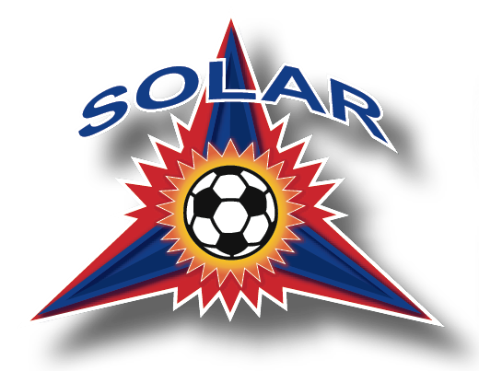

Solar Soccer Club Logo Policy
Solar Soccer Club takes pride in our logo that athletes wear to represent the organization. The logo can only be used by those with written authorization from the club.
Any requests to use the logo for the branding of any product or personal use will be denied. Teams are prohibited from branding product with the SSC logo.
The Solar Soccer Club logo will be provided to leagues directly upon request by the league.
Each league has their own policy regarding the use of the league logo. Be aware of copyright infringement and policy.
See Uniform Policy for more information regarding sponsorship branding.

